72 THE LEAGUE  PROPERTY FACT SHEET · SEASON 1 · GOLS PARTNERSHIPS — WEEK 1 | 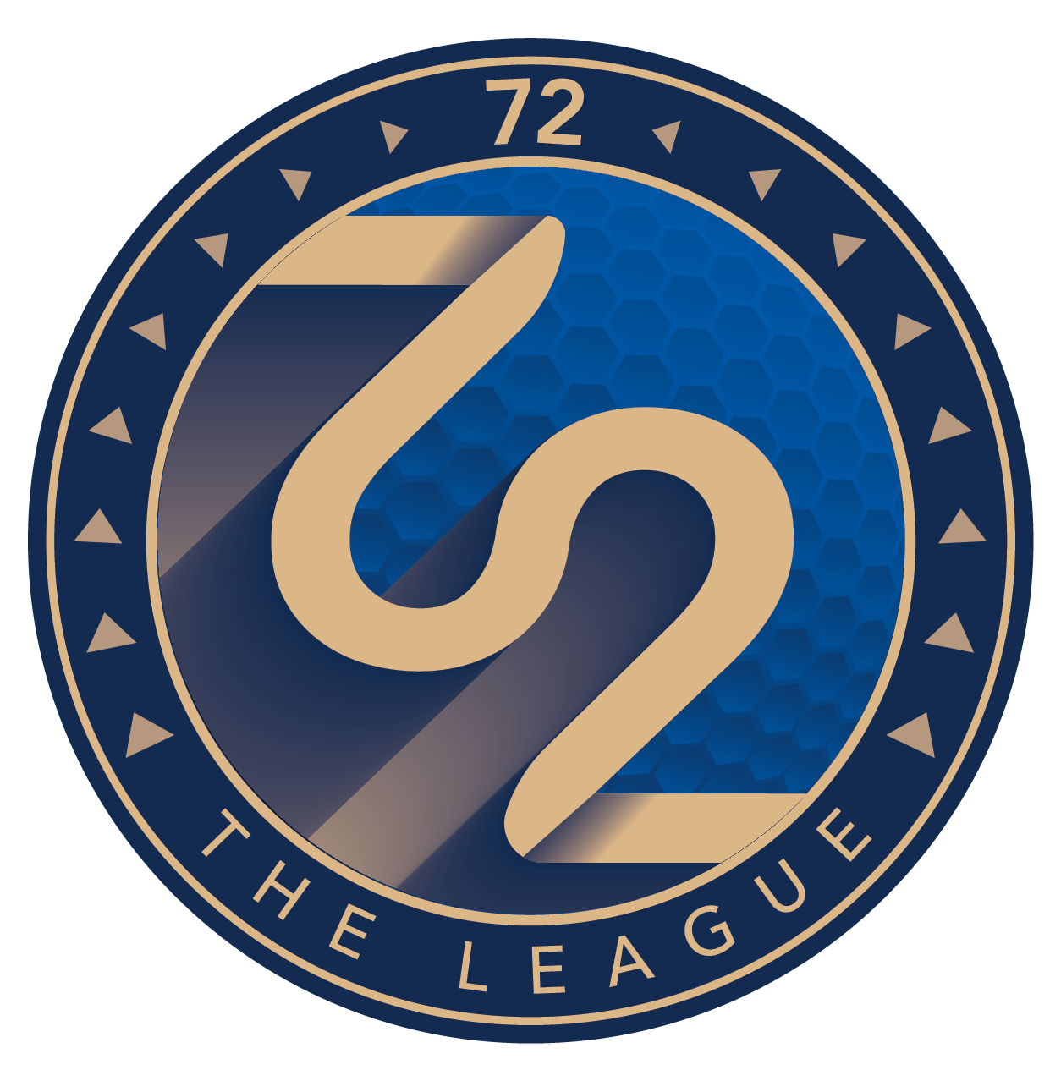

FORMAT | India's exclusive, PGTI-sanctioned professional golf league, recognized by the International Golf Federation (IGF).  - 6 city-based franchises  - 10 players per team — 60 players total, filled via player auction  - Match play format  - 2-week league calendar
DATES | Season 1: 21 February – 6 March 2026 | Player auction: January 2026  Season 1 is the only edition completed to date; Season 2 is upcoming (see below).
VENUE | Season 1 — NCR: Classic Golf & Country Club, Jaypee Greens, Qutab Golf Course.  Sourced from launch press coverage — confirm final Season 1 venue list with Meenakshi.
SEASON 2 OUTLOOK | Season 2 has not yet taken place. The venue is currently proposed to be either Pune or Mumbai, with the season expected to run in the February–March window.  Final city and dates are pending confirmation.
AUDIENCE PROFILE | "The Golfer" — positioned as the most valuable customer in sport:  - Executive persona: HNIs, promoters, founders, CEOs, C-suite decision-makers  - Average household income: INR 75 lakh+  - Age range: 35–64 (peak earning years)  - Lifestyle: luxury car owners, premium credit card holders, elite golf club members, 1–2 international trips/year  - Financially savvy: active in capital markets and luxury real estate
MEDIA COVERAGE | Launch coverage: national business/sports press (ANI, Tribune News Service, and others) covered the PGTI launch of 72 The League; Kapil Dev publicly called it a strong commercial opportunity.  Season 1 broadcast (Eurosport India) — daily average reach across 4 tracked episodes:  - E1 (3/14): 95K reach, 52 min  - E2 (3/15): 66K reach, 52 min  - E3 (3/21): 44K reach, 53 min  - E4 (3/22): 60K reach, 53 min  Season KPIs: 50M+ social reach; 2–3% engagement; 100+ UGC posts on #72TheLeague; 20+ PR articles; 3–5x sponsor engagement lift.
CURRENT SPONSORS | Confirmed Season 1 partners:  No sponsors beyond these four confirmed in materials reviewed to date.
  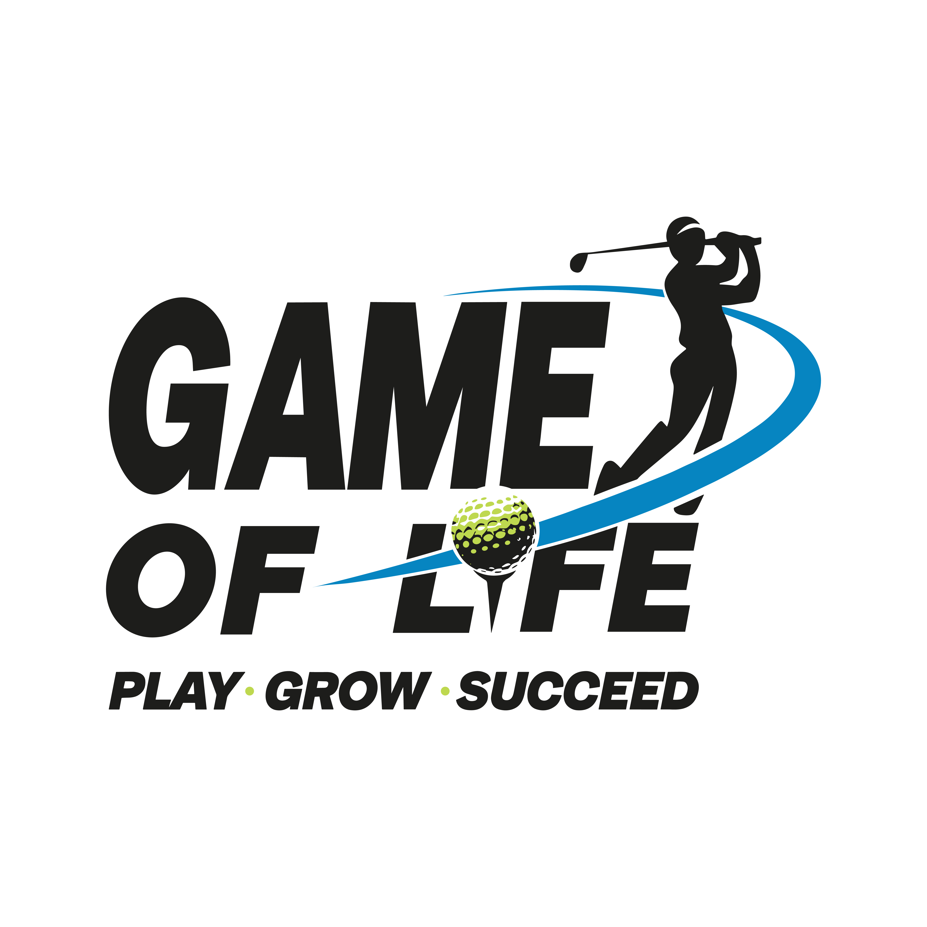 | IndusInd Bank | eurosport | 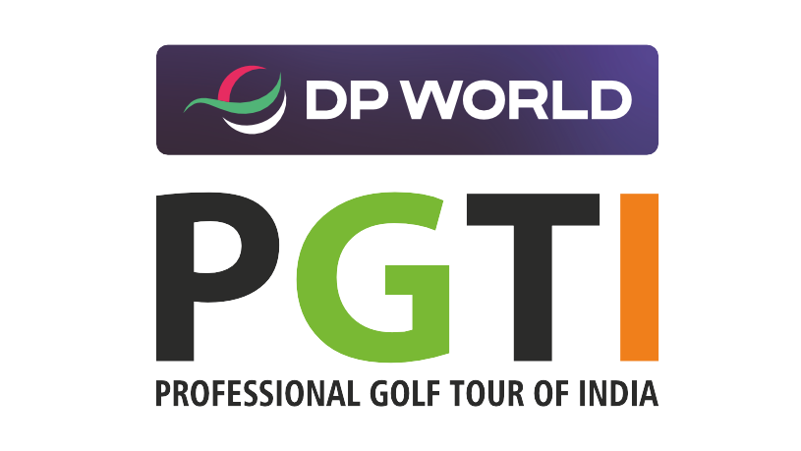
  Organising Partner | Powered By Partner | Broadcast Partner | Sanctioning Partner
INVENTORY: SOLD vs. OPEN | - Title Sponsor — INR 5 Cr — OPEN (no confirmed brand)  - Powered By Sponsor — INR 3 Cr — SOLD (IndusInd Bank)  - Associate Sponsor — INR 1 Cr — OPEN (no confirmed brand)  Confirm sold/open status directly before using in outreach.
IDEAL SPONSOR CATEGORIES | Clothing & Sports · Automobiles (EV / luxury / mobility) · Food & Beverage · Financial Services · Luxury Real Estate · Lifestyle & Furniture · Hospitality · Electronics · Aviation / Travel & Tourism
KEY DIFFERENTIATOR | - India's first exclusive, officially sanctioned pro-golf league (PGTI-sanctioned, IGF-recognized)  - ‘72’ branding signifies even par, perfection and mastery — an ambigram symbolizing balance and fairness  - Backed by industry veterans and seasoned investors for credibility, governance, scale and sustainability  - Access-driven sponsorship model — value framed as proximity to C-suite decision-makers, not just broadcast reach
Sources: 72 The League Season 1 Coverage Report, "Mother Deck for Sponsors," Season 2 sponsorship decks, GOLS Work Plan, internal correspondence (29 Jul 2026).

